Project Midas

# Summary

Project Midas is a system which allows an individual to control a computer using a gesture-recognizing device without the need for the traditional keyboard and mouse peripherals. Specifically, Project Midas has been designed to support the Myo Armband, which is a new technology that interprets EMG data to recognize gestures. Individuals using the Project Midas system will be able to perform all operations that could be accomplished with a keyboard and mouse, but Project Midas aims to be more intuitive to the user as well as completely hands-free.

# Architecture

Project Midas has been constructed as per figure 1, below. Its design allows it to be indifferent to the device that is feeding it data. However, the implementations of the system that feed data to the Shared Command Data (SCD) come from specific devices. On the Project Midas repository, an implementation of a Myo Armband data pipeline has been developed.

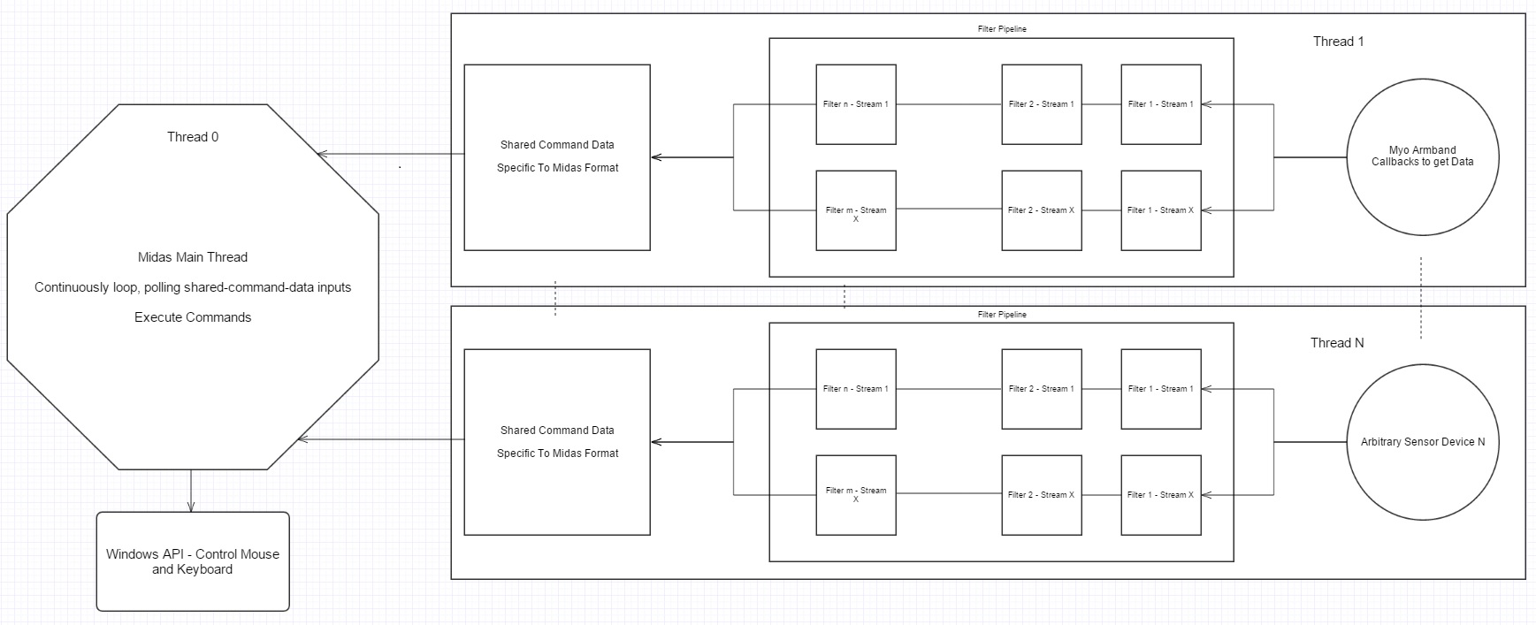

Figure 1: System Architecture

In Project Midas, only one device thread has been created, specific to the Myo Armband. Once the data has been received by the Myo Callback functions, it is passed through a filter-pipeline. The pipeline is comprised of as many filters as the specific device desires. The device simply needs to register filters that it wants to use, and the data will be piped linearly throughout them. Future work will be to develop a graph filter-pipe-architecture.

# Filters

Filters can be anything that manipulates data. To note, the final filter, which leads to the SCD must have conformant outputs, as to populate it with Midas specific data (cursor and keyboard commands). The filters currently designed in the system are shown in Table 1.

|  |  |  |  |
| --- | --- | --- | --- |
| ***Filter Name*** | ***Filter Inputs*** | ***Filter Outputs*** | ***Purpose*** |
| AveragingFilter | Sensor data, represented as floats. | Average of previous *avgCount* floats that were input. | Smooth out data from sensors by only passing a variable average of the data down the pipeline. |
| GestureFilter | Myo Gestures. | Midas specific commands for the SCD, with outlier removal. Ex: mouse click. | Translate Myo gestures into usable SCD, while also ensuring that the user intended to provide the gesture (by ensuring hold time greater than a reasonable threshold). |
| MyoTranslationFilter | Spatial data, represented as floats. | Midas specific commands for the SCD, reliant on spatial sensors from the Myo. Ex: cursor movement data, calculated from arm angles | Translate Myo sensory data into usable SCD, specifically focusing on spatial data translations. |

Table 1: Filters Currently Employed in Project Midas

As table 1 describes, there are a number of filters currently in use within Project Midas. Figure 2, below, shows the configuration of the filters, as they are currently, corresponding to the non-abstract implementation of “Thread 1, Filter Pipeline”, showing in Figure 1.

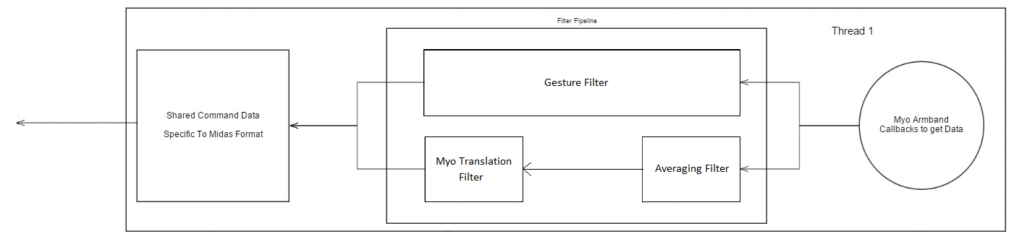

Figure 2: Configuration of Myo Specific Filter Pipeline

# Main Functionality

Midas functions by modularizing its tasks. As per figure 1, each device has its own thread, on which it receives data from a device, processes the data, and stores it in a SCD memory location. The SCD is exactly what the main thread of Midas requires.

The main thread acts as a command center. It is constantly polling all available SCD locations, retrieving commands, and then executing them. Through this cycle, it is able to obtain data in a format specific to Midas, and execute all cursor/keyboard commands.

However, commands which can be executed must be limited by some means, or else the user will have a hard time controlling their computer efficiently. Thus, a state machine is being employed to switch between modes that enable/disable certain functionality. Figure 3 shows the state transition diagram employed by Midas, and indicates the type of desired functionality in each state.

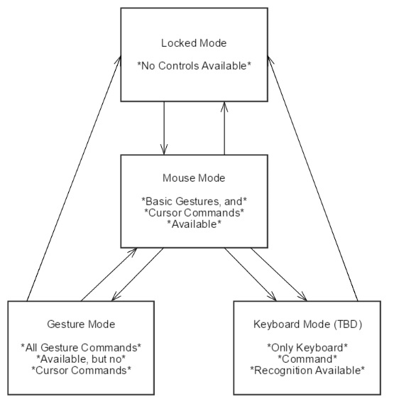

Figure 3: Midas State Transitions

The transitions between the states are not yet firmly decided upon, and the Keyboard Mode does not yet exist, but figure 3 exemplifies the desired states and legal transitions that Midas will allow. To note, the purpose of allowing some gestures in Mouse Mode is to allow for behavior such as clicking and dragging, to highlight text, or manipulate an image. Full Gesture Mode is left as a separate state, however, so that more complex gesture configurations can be implemented and recognized, giving Project Midas a powerful generalization.